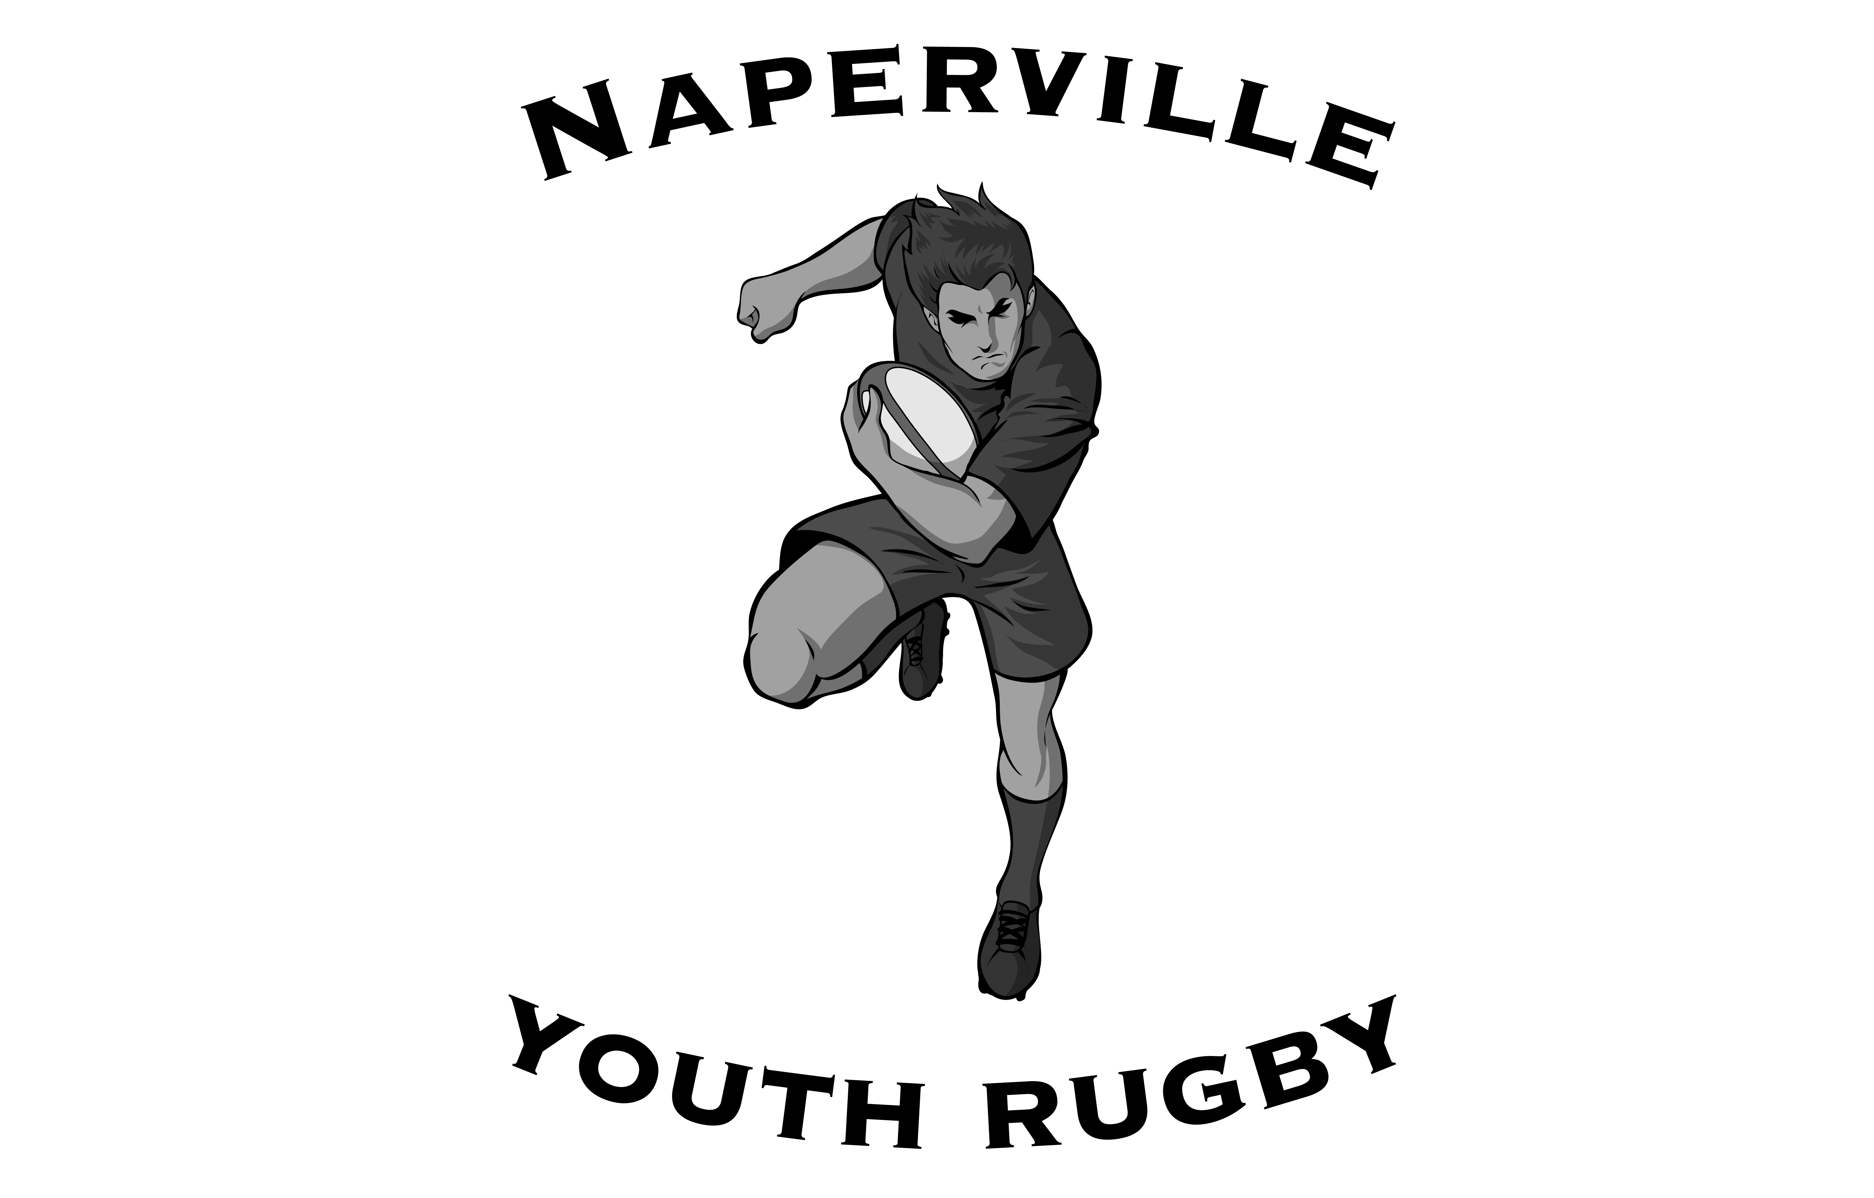
Youth Touch Rugby

Come and learn the excitement of playing rugby from experienced Naperville Area High School Rugby coaches in a POSITIVE environment. This is a non-contact program open to all 8th grade, & High School students.
Improve your fitness, hand-eye coordination and ball handling skills in fun & instructional games.
WHEN: Nov 16,23,30 WHERE: Just For Kicks
Sundays Dec 7,14,21 10200 Soccer Drive
6:30-8:30 p.m. Plainfield 60585
(630) 904 4505
justforkicks.org
COST: $150 Siblings: $75
Early registration discount of $25 if registered by Oct 31(not valid for siblings) Make checks out to Naperville Youth Rugby. Mail to address below and return with player profile(s).
Contact Graeme Jackson
Naperville Youth Rugby Phone: (630) 904-9152
11s786 Robert Dr. E-mail: nzgraeme@yahoo.com
Naperville IL 60564

