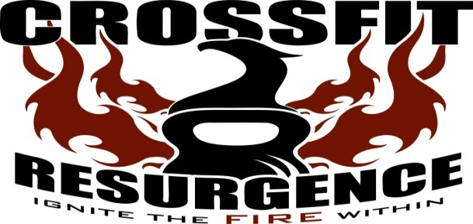

Name: ___________________________________________________________ Intro Date:_____________
Address:____________________________________________________________
City, State, Zip:_______________________________________________________
Home Phone:____________________ Cell Phone:__________________________
Date of Birth:____________________ Email:_______________________________

In an emergency, I would like CrossFit Resurgence to call:
Name:__________________________ Phone Number:_______________________

_____________________________________________________________________________________________
Health Questions

Do you: Smoke? Y N Take prescription meds? Y N
Are you exercising now? Y N If yes, how much per week?_____ Do you play sports? Y N

Do you have: Back pain, Knee pain or Shoulder pain? Y N If yes, which one____________
Previous Injuries or Surgeries? Y N High blood pressure, Asthma, Diabetes, or a Heart condition? Y N Any other health conditions not listed? Y N If yes, please explain:______________________________________________________________________

Trainer Notes: ________________________________________________________________________________________________________________________________________________________
_____________________________________________________________________________________________

Waiver and Release of Liability

Express assumption of risk: I, the undersigned, am aware that there are significant risks involved in all aspects of physical training. These risks include, but are not limited to:
falls which can result in serious injury or death; injury or death due to negligence on the part of myself, other trainers, or other people around me; injury or death due to
improper use or failure of equipment; strains and sprains. I am aware that any of these above mentioned risks may result in serious injury or death to myself and or my partner(s).
I willingly assume full responsibility for the risks that I am exposing myself to and accept full responsibility for any injury or death that may result from participation in any
activity or class while at, or under direction of CrossFit Resurgence.
I acknowledge that I have no physical impairments, injuries, or illnesses that will endanger me or others.
Initials: ________

Release: In consideration of the above mentioned risks and hazards and in consideration of the fact that I am willingly and voluntarily participating in the activities offered by
CrossFit Resurgence, I, the undersigned hereby release CrossFit Resurgence, their principals, agents, employees, and volunteers from any and all liability, claims, demands, actions
or rights of action, which are related to, arise out of, or are in any way connected with my participation in this activity, including those allegedly attributed to the negligent acts or
omissions of the above mentioned parties. This agreement shall be binding upon me, my successors, representatives, heirs, executors, assigns, or transferees. If any portion of
this agreement is held invalid, I agree that the remainder of the agreement shall remain in full legal force and effect.
If I am signing on behalf of a minor child, I also give full permission for any person connected with CrossFit Resurgence to administer first aid deemed necessary, and
in case of serious illness or injury, I give permission to call for medical and or surgical care for the child and to transport the child to a medical facility deemed necessary for the
well being of the child.
Indemnification: The participant recognizes that there is risk involved in the types of activities offered by CrossFit Resurgence. Therefore the participant accepts financial
responsibility for any injury that the participant may cause either to him/herself or to any other participant due to his/her negligence. Should the above mentioned parties, or
anyone acting on their behalf, be required to incur attorney’s fees and costs to enforce this agreement, I agree to reimburse them for such fees and costs. I further agree to
indemnify and hold harmless CrossFit Resurgence, their principals, agents, employees, and volunteers from liability for the injury or death of any person(s) and damage to
property that may result from my negligent or intentional act or omission while participating in activities offered by CrossFit Resurgence, at the main building or abroad. This
includes but is not limited to parks, recreational areas, playgrounds, areas adjacent to main building, and/or any area selected for training by CrossFit Resurgence.

I have read and understood the foregoing assumption of risk, and release of liability and I understand that by signing it obligates me to indemnify
the parties named for any liability for injury or death of any person and damage to property caused by my negligent or intentional act or omission.
I understand that by signing this form I am waiving valuable legal rights.
Signature of participant: _______________________________________ Date: __________

------------------------------------------------------------------------------------------------------------------------------------------------------------
If the participant is under the age of 18,
Signature of Parent/Guardian: __________________________________________________
Print Name: _______________________________________________ Date: ______________

_____________________________________________________________________________________________
Reviewed By (Print): _______________________________
Signature: ___________________________________
Date: ___________________

